1. **Introduction**
   1. Background and Context

In today's rapidly evolving business landscape, organizations face increasing challenges in managing their most valuable asset: their workforce. Traditional methods of employee data management, often relying on paper-based systems or disparate digital tools, have become inadequate in meeting the demands of modern HR operations. These outdated approaches frequently lead to inefficiencies, data inconsistencies, and difficulties in accessing crucial information when needed. As companies grow and workforce dynamics become more complex, the need for a centralized, efficient, and secure system to manage employee data has become paramount.

The advent of digital transformation across industries has highlighted the critical role of data in decision-making and operational efficiency. Human Resources departments, in particular, require real-time access to accurate employee information to support strategic planning, compliance reporting, and day-to-day operations. Moreover, with the increasing focus on employee experience and engagement, there's a growing need for systems that not only serve the organization but also empower employees by providing them with easy access to their personal information and the ability to update it.

Furthermore, the rise of remote work and distributed teams has amplified the importance of having a robust, accessible employee database management system. Organizations need solutions that can securely manage sensitive employee data, comply with data protection regulations, and provide authorized access from anywhere, at any time. Additionally, as businesses increasingly rely on data-driven insights for workforce planning and development, there's a growing demand for systems that can not only store and manage data but also provide analytical capabilities to support strategic HR initiatives. These evolving needs in the corporate world create a strong case for advanced Employee Database Management Systems that can adapt to changing business requirements while ensuring data integrity, security, and accessibility.

* 1. Relevance

Given the evolving needs in employee data management, EmpTrack emerges as a highly relevant solution addressing the critical challenges faced by modern organizations. By offering a comprehensive, secure, and user-friendly platform for managing employee information, EmpTrack directly responds to the pressing need for centralized, efficient, and accessible HR data systems. Its modular architecture, incorporating advanced features such as role-based access control, real-time updates, and department-specific dashboards, aligns perfectly with the complex requirements of contemporary workforce management. The system's ability to streamline HR operations, enhance data accuracy, and empower employees to manage their own information addresses the dual objectives of improving organizational efficiency and enhancing employee engagement.

Moreover, EmpTrack's utilization of modern technologies like Python, Streamlit, and MySQL demonstrates its relevance in the era of digital transformation. By providing a scalable, secure platform that can handle the demands of both on-site and remote work environments, EmpTrack positions itself as a forward-thinking solution capable of adapting to the changing landscape of work. Its emphasis on data integrity, coupled with features that support strategic HR initiatives through accessible data and analytics, makes EmpTrack a timely and valuable tool for organizations seeking to leverage their workforce data for better decision-making and operational excellence.

* 1. Literature Survey

A thorough literature survey involved exploring and discussing previous studies, research, and technological developments related to the project’s theme. For the project **EmpTrack: Employee Database Management System**, this included examining existing tools and software that support employee records, database management, and user interface design. Key areas reviewed are as follows:

* **Human Resource Information Systems (HRIS):** The study by Johnson, Lukaszewski, and Stone (Year Not Provided) investigates the evolution of Human Resource Information Systems (HRIS), exploring the co-evolution of technology and HR processes. This work highlights the critical relationship between technological advancements and the efficiency of HR practices, underscoring the importance of system adaptability to evolving HR needs.
* **Database Design for Employee Management:** Morris (2016) provides comprehensive guidelines for relational database design, applicable to employee data management systems. This study emphasizes the principles of designing relational databases that can efficiently handle employee records, ensuring that systems are robust and scalable to accommodate complex data requirements. These guidelines are fundamental to building a reliable backend for employee information storage.
* **User Interface Design Principles:** Shneiderman et al. (2016) introduce Shneiderman’s Eight Golden Rules for effective user interface design. This set of principles focuses on consistency, feedback, and error prevention, aiming to create interactive systems that are user-friendly and reduce the likelihood of user error. These rules are crucial in designing interfaces for employee management software, enhancing usability and user experience.

This literature survey provided a foundational understanding of the principles that guided the design and functionality of systems related to employee management. The studies mentioned offered valuable insights for developing a comprehensive Employee Database Management System that is efficient, user-friendly, and adaptable.

* 1. Motivation

The project aims to address the growing challenges in employee data management faced by modern organizations. As businesses expand, traditional methods become inadequate, leading to inefficiencies and data inaccuracies. EmpTrack is driven by the goal of creating a streamlined, efficient solution that empowers HR departments with accurate data and valuable insights for strategic decision-making.

The project is motivated by the belief that employee data management should enhance both organizational success and employee satisfaction. By developing a user-friendly system that engages employees and gives them control over their information, EmpTrack seeks to set a new standard in EDMS. It demonstrates how technology can create more responsive, efficient, and employee-centric organizations.

* 1. Aim of the Project

The aim of this project is to develop an Employee Database Management System (EDMS) to streamline human resource operations and improve employee data management. It addresses challenges in workforce data handling, limited access control, and manual HR tasks. With a secure, user-friendly, and role-based system, EmpTrack automates routine HR processes, enhances data accuracy, and enables seamless access and management.

* 1. Scope & Objectives

**Scope:**

* **Employee Information Management**: Comprehensive handling of employee data, including personal and professional details.
* **Multi-department Support**: Tailored interfaces and functionalities for various departments within the organization.
* **User Authentication and Access Control**: Secure login system with role-based access to different features.
* **Self-service Portal**: Allowing employees to view and update their own information within set parameters.

**Objectives:**

* To create a **secure and scalable** system using MySQL and Streamlit, capable of efficiently managing employee data across the organization.
* To develop an **intuitive and responsive** user interface that caters to both administrative and employee needs.
* To implement **role-based functionalities** that support various organizational processes, from HR management to individual data updates.
* To ensure **data integrity and privacy** through robust validation mechanisms and proper authentication protocols.

To design a **flexible and maintainable** system that can adapt to organizational changes and future requirements.

* 1. Technical Approach

EmpTrack is built using Python with Streamlit for the frontend and MySQL for the backend. The system follows a modular architecture, with separate Python files handling distinct functionalities like authentication, data operations, and role-specific dashboards. This approach enhances maintainability and scalability. The application uses MySQL Connector for Python for database interactions and implements a simple authentication mechanism with session management through Streamlit's session state.

Streamlit is used to create a responsive UI that dynamically renders based on the user's role (HR, Tech, Sales, Customer Success). The system features role-based access control, real-time updates, and department-specific dashboards. Data validation is performed both client-side and server-side to ensure integrity. The project efficiently utilizes Streamlit's capabilities for layout, form handling, and state management to provide a seamless user experience for employee data management.

1. **System Analysis**
   1. Software requirement specification

* **Operating System:** Any operating system capable of running Python and MySQL (e.g., Windows, macOS, Linux)
* **Programming Language:** Python 3.x
* **Web Framework:** Streamlit
* **Database Management System:** MySQL
* **Python Libraries:** streamlit, mysql-connector-python, pandas
* **Development Environment:** Any Python IDE or text editor (e.g., Visual Studio Code, PyCharm)
* **Web Browser:** Any modern web browser (e.g., Chrome, Firefox, Safari, Edge)
  1. Hardware requirement specification
* **Processor:** Multi-core CPU (e.g., Intel Core i5 or equivalent)
* **RAM:** Minimum 8GB, recommended 16GB or higher
* **Storage:** At least 256GB SSD for fast database operations
* **Network:** Ethernet connection with at least 100 Mbps speed

1. **System Design**
   1. ER Diagram

This ER diagram depicts an employee management system with three entities. It shows relationships between employee personal data, job details, and salary information, linked by emp_id and organizational level across the entities.

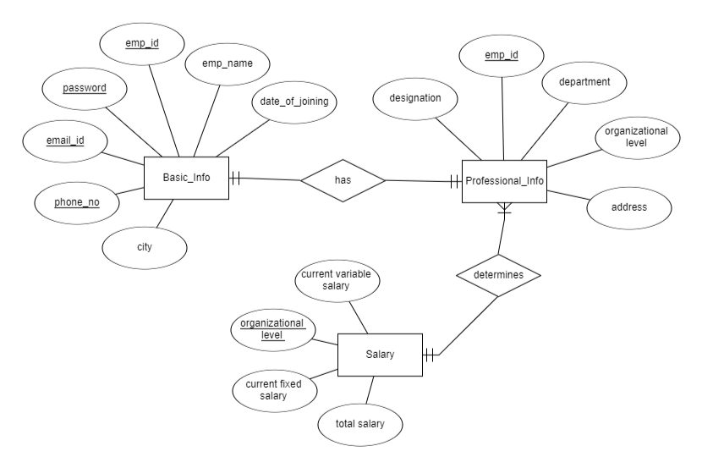

*Fig. 3.1.1 ER Diagram*

* 1. Database Table Design

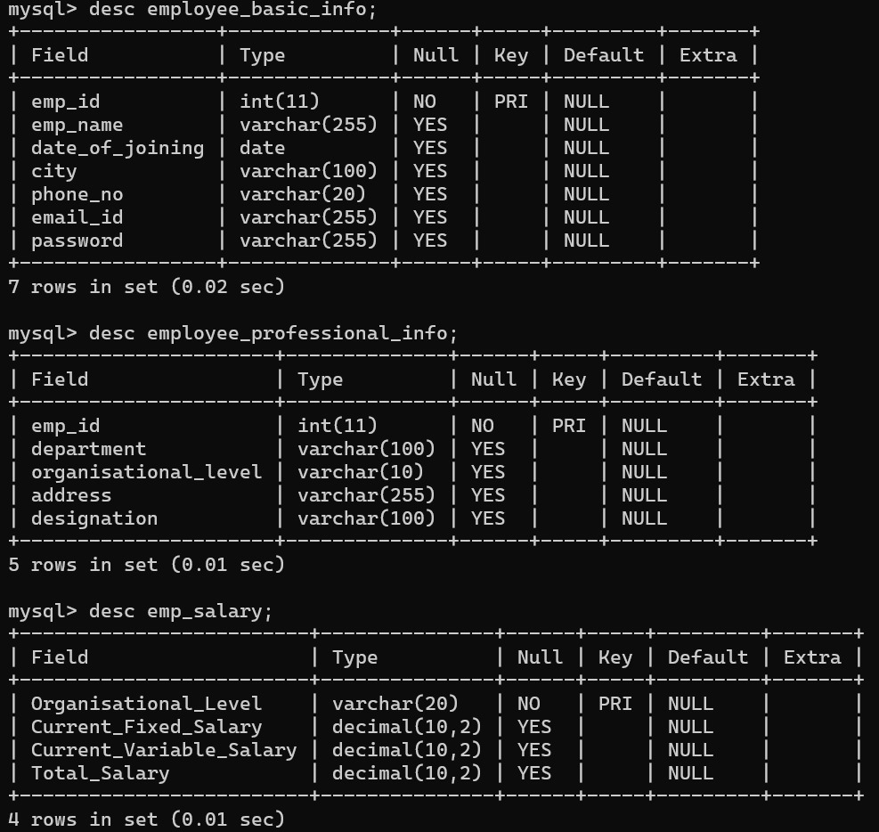



*Fig. 3.2.1 Tables in Database*

These images show MySQL table structures for an employee database. There are three tables: employee_basic_info for personal details, employee_professional_info for job-related information, and emp_salary for compensation data. The tables are linked by emp_id and organizational_level fields, reflecting the ER diagram's relationships.

* 1. Data Flow Diagram

This flowchart outlines a departmental employee database management system. Users begin by logging in, accessing a central database, and then viewing a department-specific dashboard. This personalized approach ensures employees interact with relevant information. The system allows for department-specific CRUD operations, enabling tailored data management within each unit. This functionality lets users update, view, and manage employee information contextually. The process concludes with a logout step, maintaining security. Overall, this flowchart represents a streamlined, secure approach to employee data management. It balances user accessibility with data protection and respects organizational structure, providing a efficient system for handling employee information within departmental boundaries.

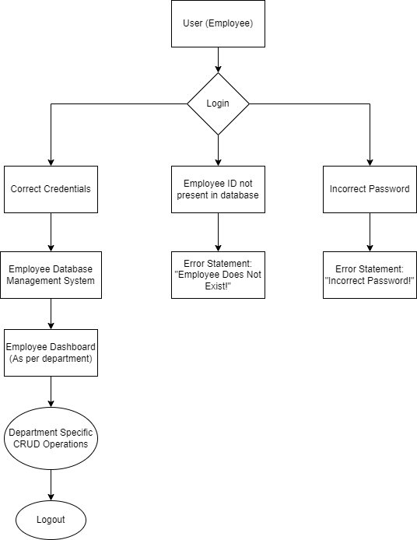

*Fig. 3.3.1 Flow of Data*

* 1. Specific Requirements

Here are specific requirements for the EmpTrack Employee Database Management System project:

* User Authentication and Access Control Implement a secure login system with role-based access for HR and other departments.
* Employee Data Management Enable HR to view, add, update, and delete employee records, including personal and professional details.
* Department-specific Dashboards Create tailored dashboards for different departments, allowing employees to view and update their own information.

1. **Implementation, Testing and Debugging**
   1. Module Description

The project is implemented using Python with the Streamlit framework for the user interface. The main.py file serves as the core module, integrating various functionalities such as user authentication, employee data management, and department-specific dashboards. It uses MySQL for database operations, connecting to the "Emp_DBMS" database.

* 1. Integration Testing

The system integrates multiple components, including user authentication, role-based access control, and CRUD operations for employee data. Integration testing would involve ensuring smooth interaction between these components, such as verifying that HR users can access all functionalities while other department users have limited access.

* 1. Database Connections and Code Implementation

Database connection is established using mysql.connector. The connection details (host, user, password, database) are hardcoded in the script. A cursor object (mc) is created to execute SQL queries. The implementation follows a modular approach with functions for different operations, improving code readability and maintainability.

* 1. Retrieving Data from the Database

Data retrieval is implemented through SQL SELECT queries. For example, the get_employee_details function fetches an employee's information using their employee ID. The get_department_employees function retrieves all employees from a specific department. These functions use parameterized queries to prevent SQL injection.

* 1. Saving Data into the Database

New employee data is saved using an INSERT query in the "Add New Employee" section. The implementation includes input validation (e.g., checking email format, phone number length) before inserting data. Error handling is implemented to catch and display any database errors during the insertion process.

* 1. Updating Records into the Database

The system allows updating employee details through UPDATE queries. The update_employee_field function is a generic method for updating single fields. In the HR dashboard, there's a dedicated section for comprehensive employee updates. The implementation includes input validation and error handling for update operations.

* 1. Deleting Data from the Database

Employee deletion is implemented in the HR dashboard. It uses a DELETE query based on the employee ID. The implementation includes a confirmation step to prevent accidental deletions. Error handling is in place to catch and display any issues during the deletion process.

Following is the Step-Wise Implementation of the Project –

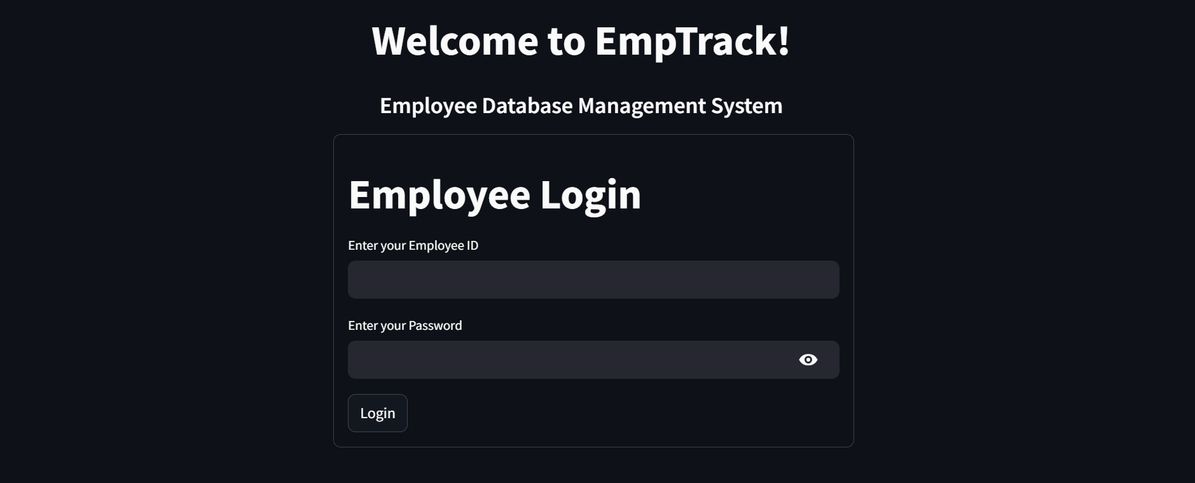

*Fig. 4.1 Login Page*

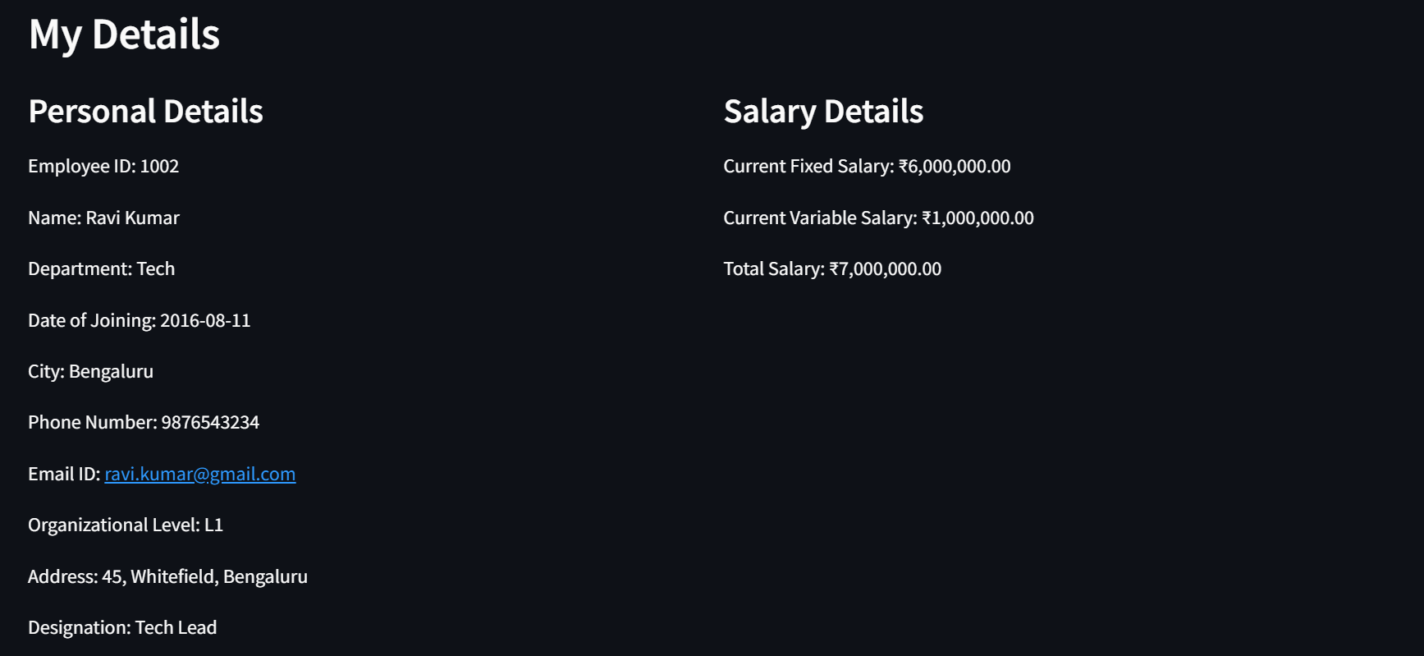

*Fig. 4.2 Dashboard available for each employee*

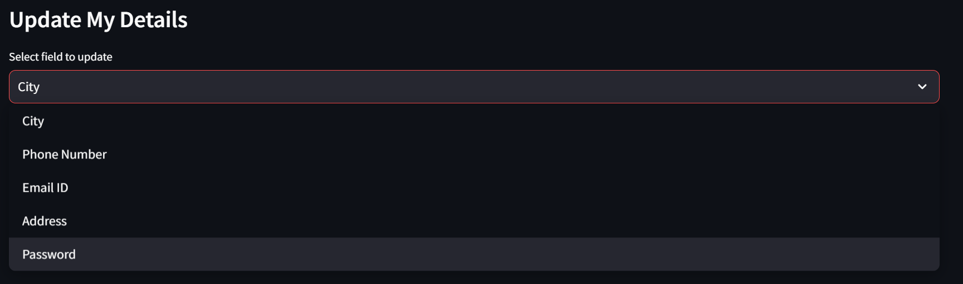

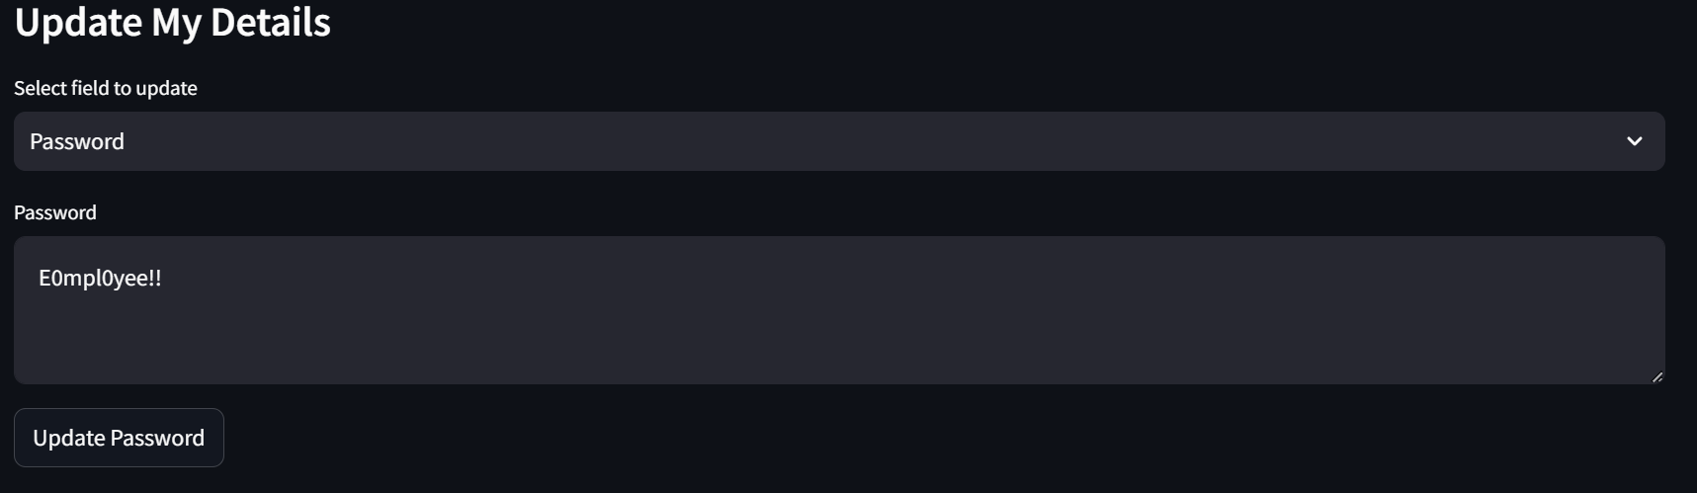

*Fig. 4.3 Functionality to make updations in the records*

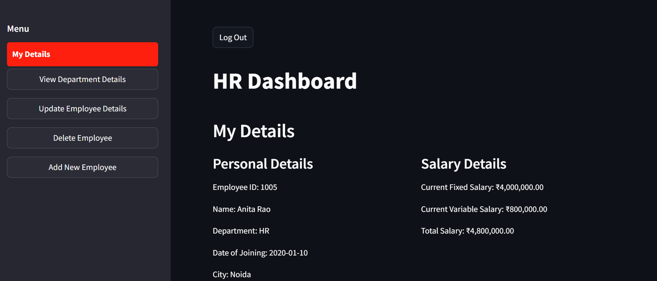

*Fig. 4.4 Dashboard available for employee of HR department (admin rights)*

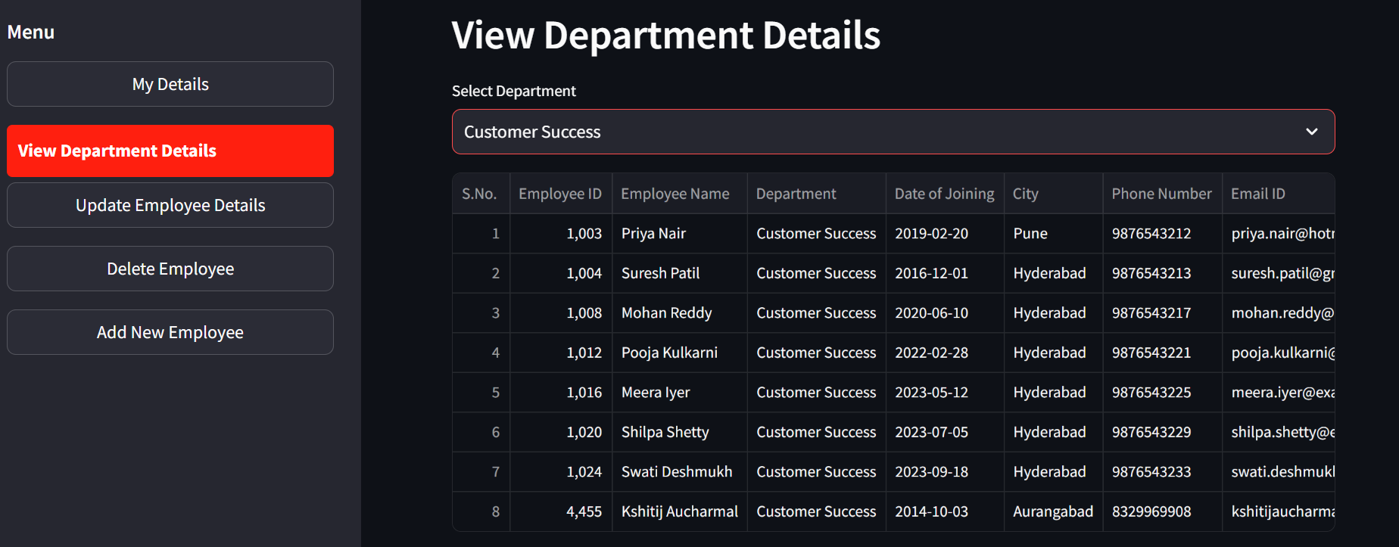

*Fig 4.5 Functionality to view details of employee in a specific department*

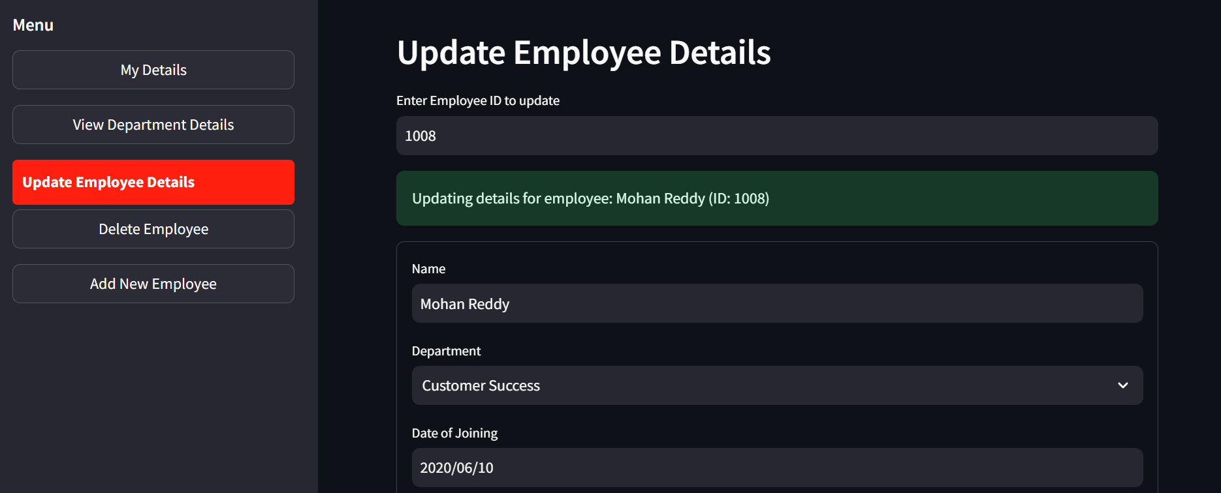

*Fig. 4.6 Functionality to update details of an employee*

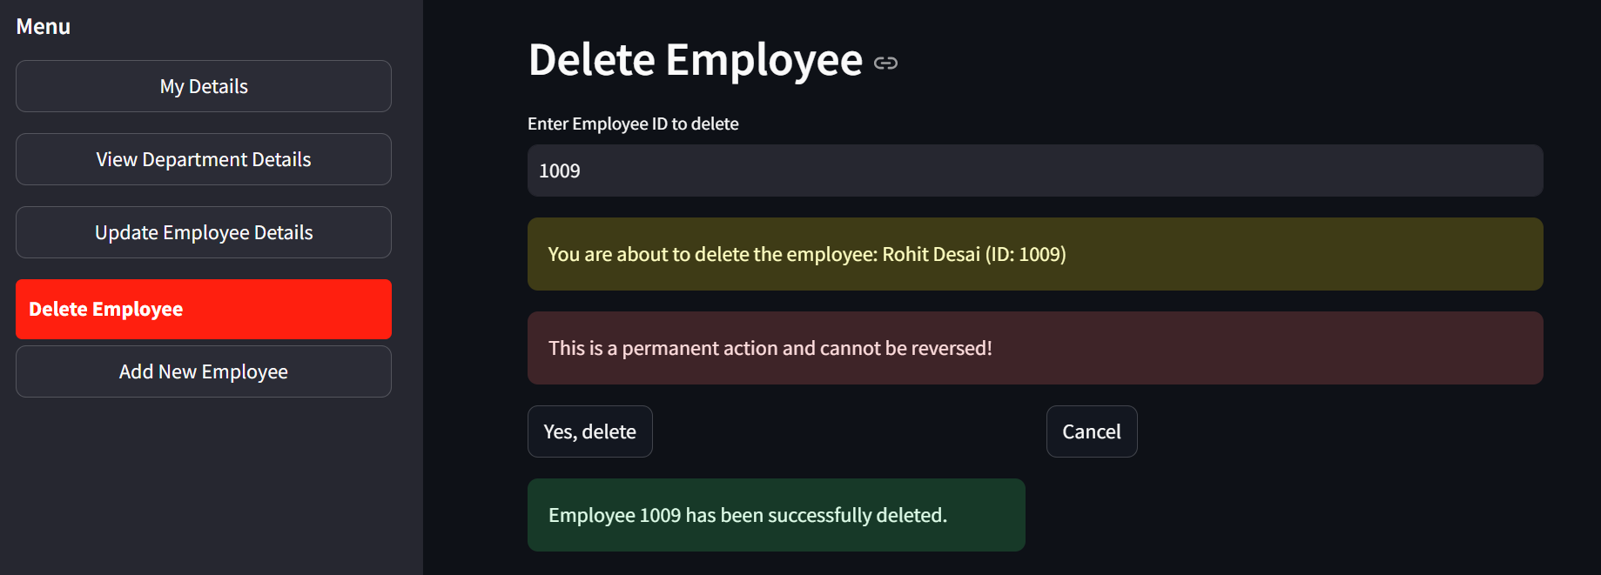

*Fig. 4.7 Functionality to delete an employee throughout the database*

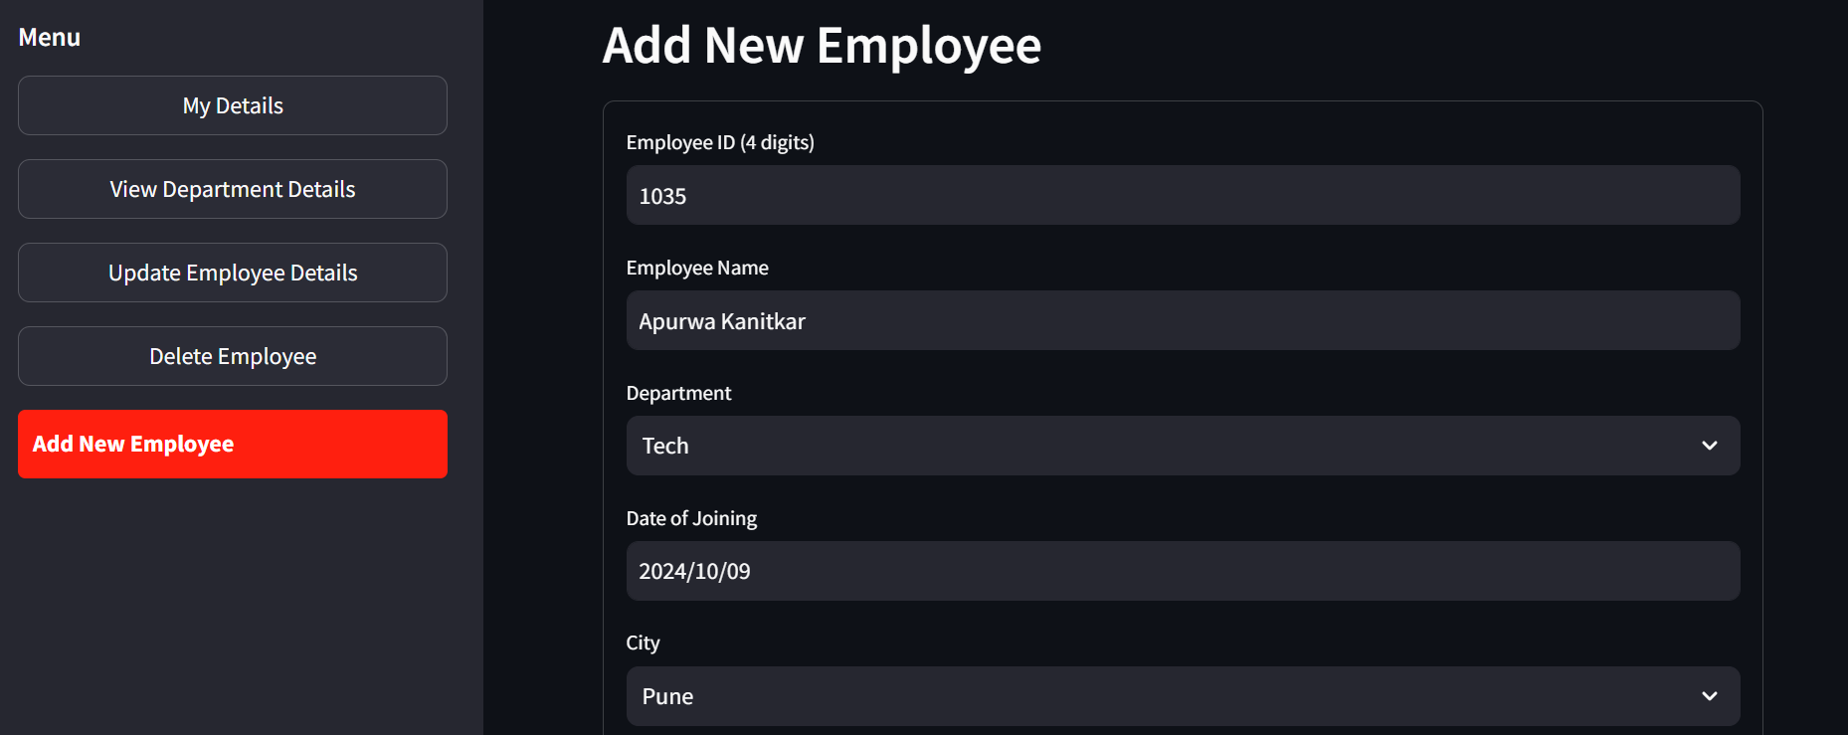

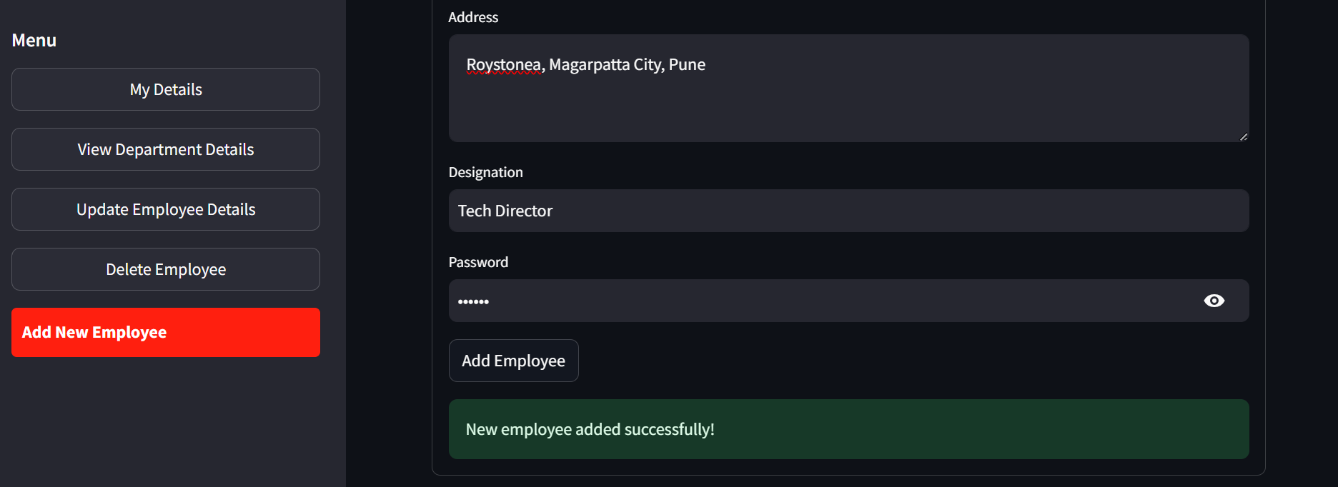

*Fig. 4.8 Functionality to add new employee*

1. **Results and Discussion**

The implementation of the EmpTrack Employee Database Management System has yielded correct expected results in streamlining HR processes and improving data management for an organization. The user authentication system effectively controls access, ensuring that employees can only view and modify information appropriate to their roles. HR personnel would also experience efficiency in managing employee records, with the ability to easily add new employees, update existing information, and perform necessary deletions when required. The department-specific dashboards could providing employees with a personalized view of their information and allowing for self-service updates to certain fields.

1. **Conclusion and Future Scope**

The implementation of role-based access and tailored dashboards has enhanced data security while providing a user-friendly interface for employees across different departments. Overall, EmpTrack has demonstrated its value as a centralized solution for employee information management, streamlining HR processes and improving data accuracy.

Looking towards the future, there is significant scope for expanding EmpTrack's capabilities. Potential enhancements could include integrating advanced analytics for workforce insights, implementing a mobile app and adding features for performance management. Additionally, the system could be extended to support multi-language interfaces for global organizations and incorporate AI-driven chatbots for employee queries. As organizations continue to evolve in the digital age, EmpTrack has the potential to grow into a comprehensive human resource information system, further optimizing HR operations and supporting strategic decision-making.

1. **References**

[1] Mark Lutz, Learning Python, 5th Edition, O'Reilly Media, Inc., 2013, pp. 1-1600.

[2] Paul DuBois, MySQL Cookbook: Solutions for Database Developers and Administrators, 3rd Edition, O'Reilly Media, Inc., 2014, pp. 1-866.

[3] Luke Welling, Laura Thomson, PHP and MySQL Web Development, 5th Edition, Addison-Wesley Professional, 2016, pp. 1-688.

[4] Ramez Elmasri, Shamkant Navathe, Fundamentals of Database Systems, 7th Edition, Pearson, 2015, pp. 1-1272.

[5] Abraham Silberschatz, Henry F. Korth, S. Sudarshan, Database System Concepts, 7th Edition, McGraw-Hill Education, 2019, pp. 1-1376.

[6] Snehan Kekre, "The Streamlit Book: The Ultimate Guide to Building Web Apps with Streamlit," Amazon Digital Services LLC - KDP Print US, 2022. [Accessed Oct. 9, 2024].

[7] Ashley Westbrook, Building Data Science Applications with Streamlit: Develop and deploy efficient machine learning applications with Python, Packt Publishing, 2021, pp. 1-392.